EFI Hardware
7 Monomeeth Drive, Mitcham
Victoria, Australia. 3132
Phone 61 3 9873 5400 Fax 61 3 9873 5955
Email Steve@efihardware.com
Web www.efihardware.com



Toyota 20 valve ram tubes

We now have available Pro-Series Ram Tube Kits for Toyota 20 valve silver top and black top motors
The Pro-Series Ram Tubes feature a CNC machined clamping base. This enables the ram tube to be shortened if required. Available sizes are:

# 832-001K Silver Top kit # 832-002K Black Top Kit
105mm long (can be shortened to 68mm)

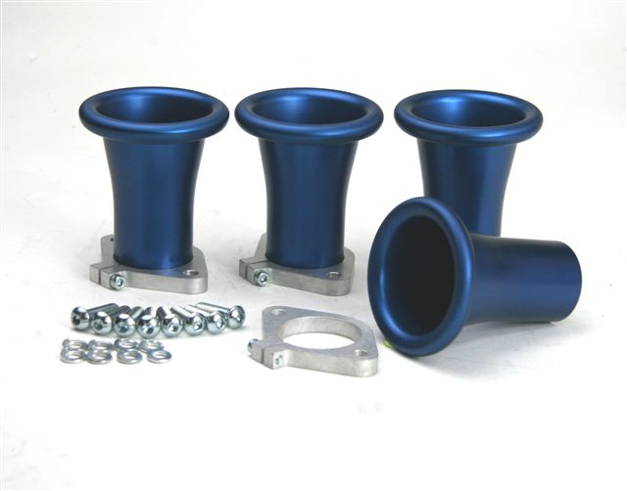
# 832-001KL Silver Top kit # 832-002KL Black Top Kit
150mm long (can be shortened to 70mm)

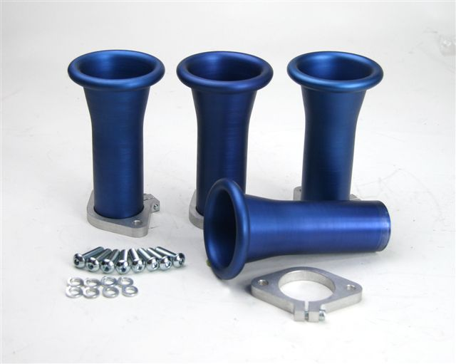

# 832-001KEL Silver Top kit # 832-002KEL Black Top Kit 200mm long (can be shortened to 150mm)

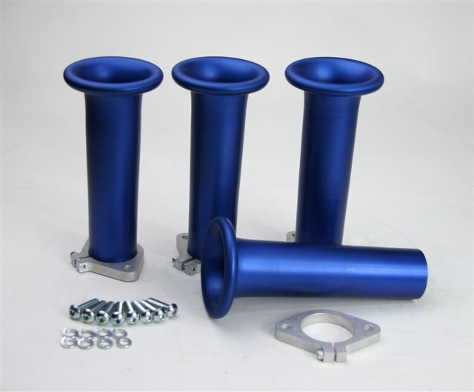

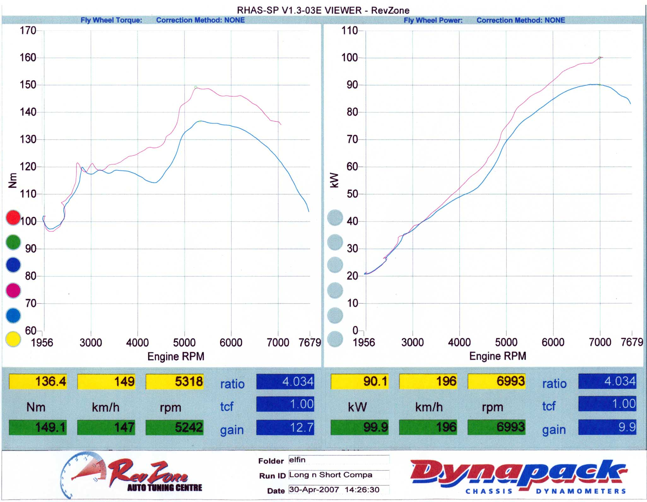

This Dyno test was on an engine with mild cams and exhaust between STD Toyota Ram Tubes and 832-001KL 150mm long Pro-Series Ram Tubes. The result is an increase of 14% @ 4400 RPM in torque and 11% increase in HP @ 7000 RPM

